6/15/2021

FINAL EXAM CS 767 SUMMER 2021

Please respond to the following question as concretely and as clearly as you can, citing specifics from your assignment work i.e., avoid generalities (statements that apply to most applications of the overall type). Use your own words. Where you have no clear conclusions, describe the relevant trade-offs. Each question will be evaluated using the following table.

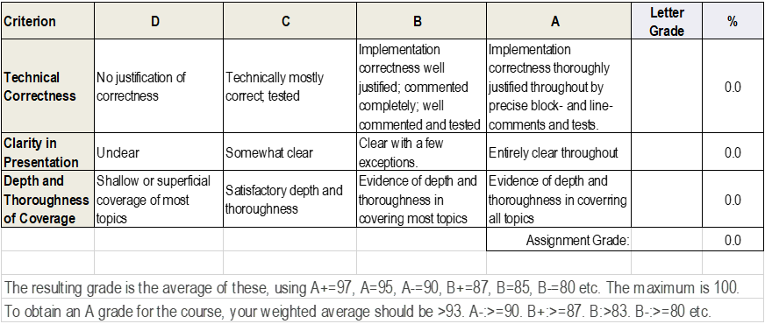

Typical question forms:

Describe a practical problem amenable to … <a designated machine learning approach> …

… turn your … <a designated machine learning approach> … assignment into a useful, different practical application …

Give a machine learning application that is very unlikely to be solvable with <a designated machine learning approach> … explain …

How could you have used … <a designated machine learning approach> … to satisfy your term project requirements …

If you’d had more time, what additional hyperparameters or data enhancement work would you have performed on … <a designated machine learning approach>… explain …

**Question 1 (and all 5 questions):** Please answer part P (for term projects) *or* partT (for topical assignments).

1P. …

1T. …

**Question 2:** Please answer part P (for term projects) *or* partT (for topical assignments).

2P. …

2T. …